Practical Gaming 2024

Name of Student
Jack O’Mahoney

T-Number
T00261288

Name of Project
WaveLite

Gameplay
Wave Based 3rd Person Rogue Lite Game with buff/item selection after each wave as well as chests that spawn to help with progression.
WaveLite FullGame is the finished game scene in the unity project.
Movement
- W = Walk Forward
- A = Walk Left
- S = Walk Backwards
- D = Walk Right
- Space = Jump
- Ctrl = Slide
- Camera Movement will be done with the mouse
Basic Buffs include Movement Speed, Attack Speed, Projectile Speed and Increased HP.
A lot of game setting’s for example the wave that the boss spawns on can be changed in the inspector of the game

Coding
Under each of the following headings, please describe the concept, why is it or isn’t it useful/needed, where do you implement in your project, you may provide screenshots or cut and past code segments etc..

- Frame Rate Independence
Frame Rate independence just makes sure that the gameplay runs the same regardless of the players FPS
In my project it is used in my movement and spawning systems through the use of Time.fixedDeltaTime with unitys physics system in the PlayerMovement Script and WaitForSeconds( ) in the WaveSpawner Script
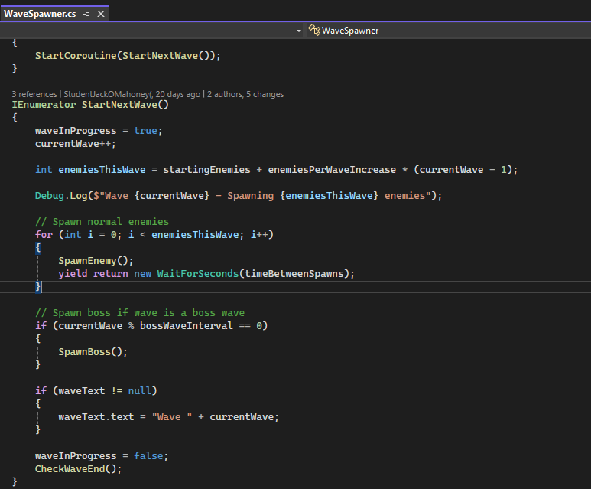
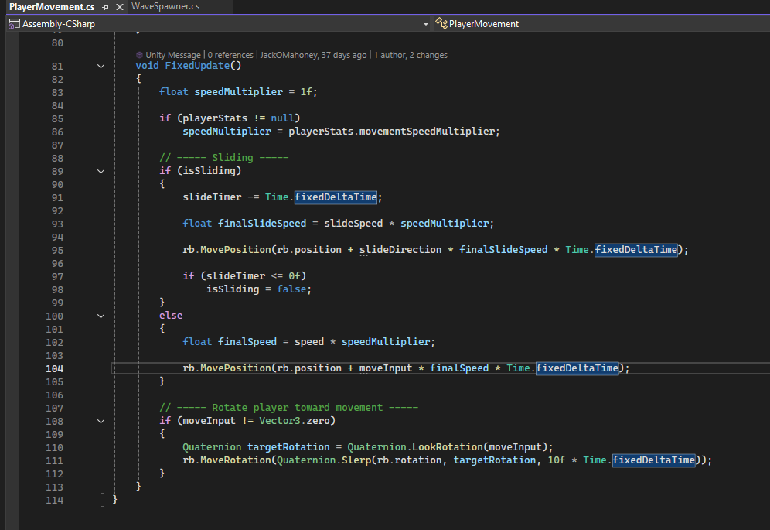
- Interfaces
A contract that multiple scripts can implement
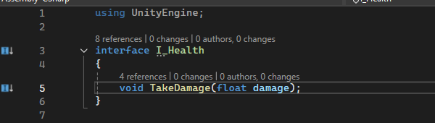
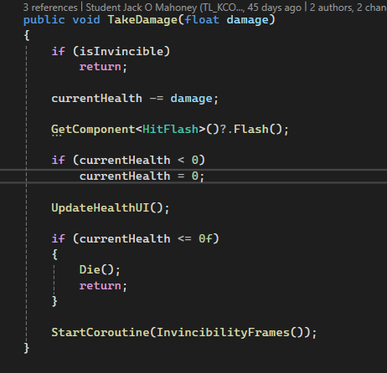

- Inheritance
Inheritance just lets one class to inherit the behaviour from another class
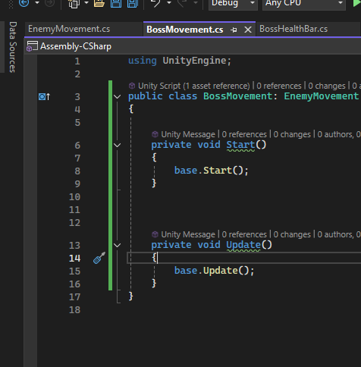
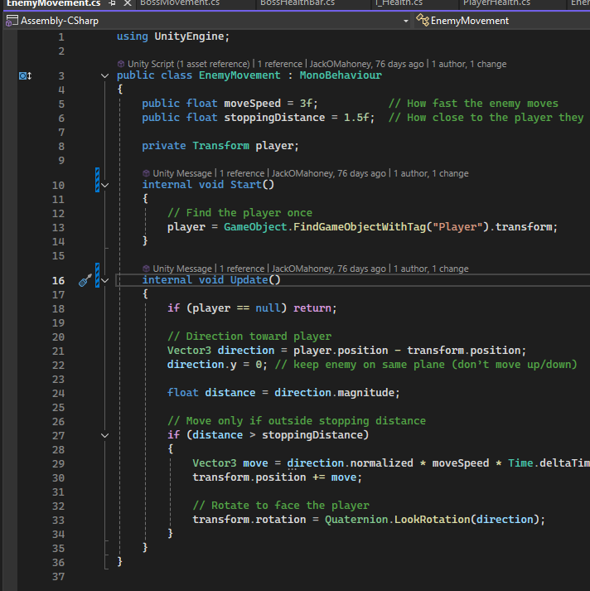

- Case pattern
A case pattern (Switch) is used to control different behaviours based on a condition or state
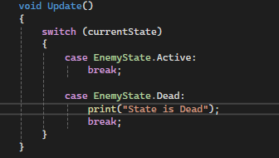
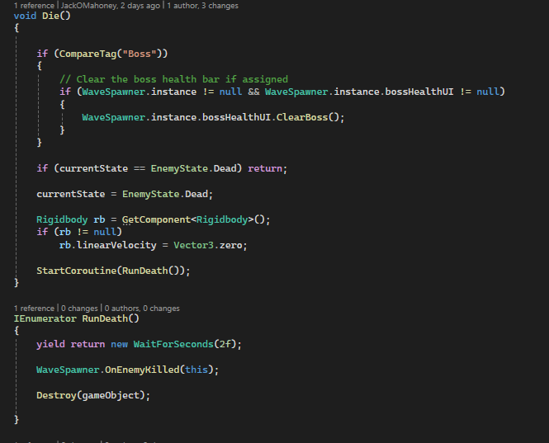
- Observer Pattern
The observer pattern is just how objects react to events so for my project it would be used when the bosss spawns it calls the enemy health list with a method yay that prints out yay!! In the console
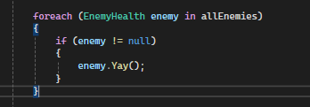

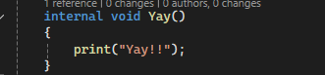

- Polymorphism
Polymorphism allows different objects to use the same method to produce different results in my project im using the enemy health to hit the enemy with a projectile aswell as have it so the enemy says ow when hit
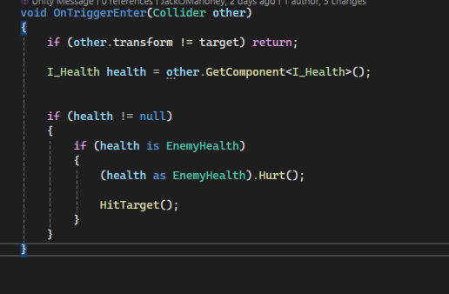
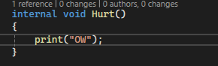

- Communication between scripts/game objects
This is the communication between scripts so in this case in my project the Interface I_Health is communicating with the EnemyHealth script with the takedamage method
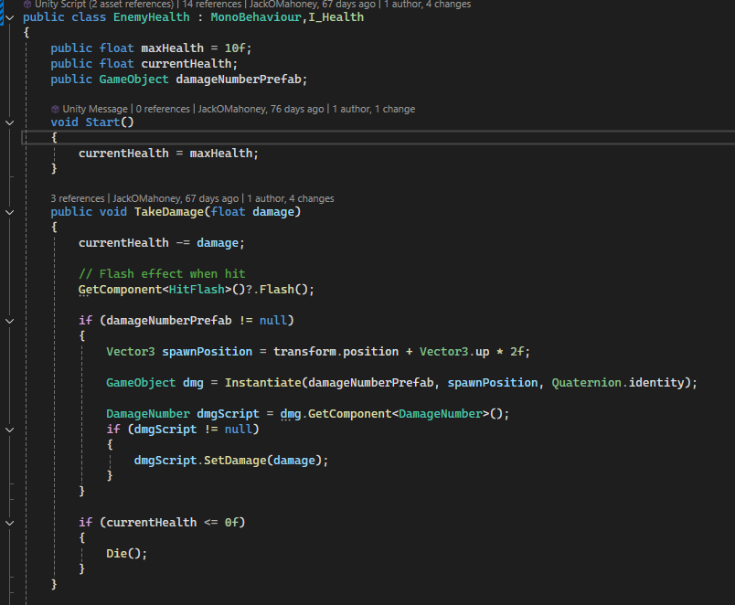
- Instantiation and Prefabs
This is where Objects are created during runtime from prefabs in my project its used in the spawning of the Enemies/Bosses and the Chests withing the WaveSpawner and ChestSpawner Scripts.
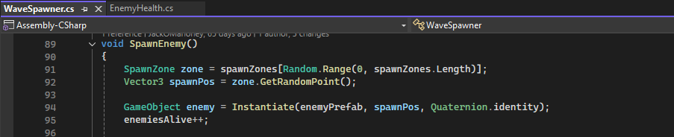

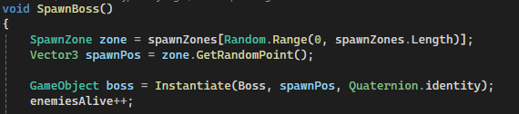

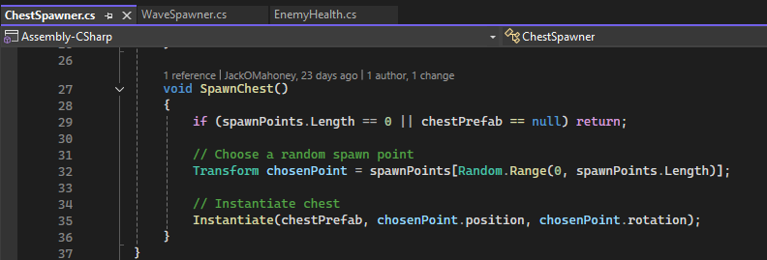

- Magic Numbers
Magic Numbers are the Hardcodes values in scripts that should be avoided for the most part unless needed
In my project this would have been used for things like the starting enemies that spawn the amount the enemies increase per wave aswell as things like the players slide speed and the enemies movement speed and their damage these are public variables that can be changed in the inspector before runtime in a testing sense but they are mainly hardcoded values
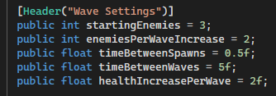
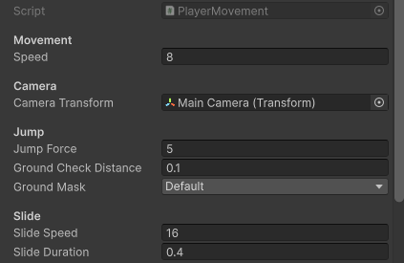

- Model Animation
This is just the Animating of objects to improve the visuals
Ive used this when the player opens a chest a videoplayer is displayed and plays a video of the chest opening
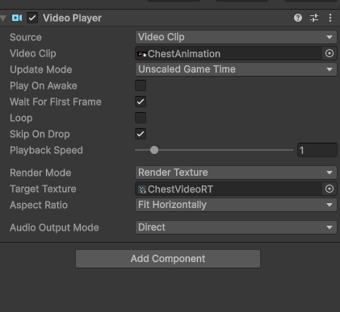

- Self made models and or animations
This is just the making of custom assets that were made or modified so for my project this is just the Chest Model I made
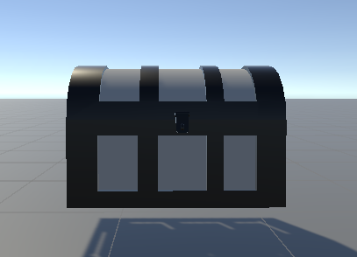

- Interactions between objects/scripts
This is when Objects are responding to the player or other objects and the Scripts within them so in my project this would be something like my Chest interaction system so in my case in the ChestInteraction script the onTriggerEnter/Exit interact with the player to see if their in range to see the text prompt to be able to use the Input.GetKeyDown(KeyCode.F) to open the chest
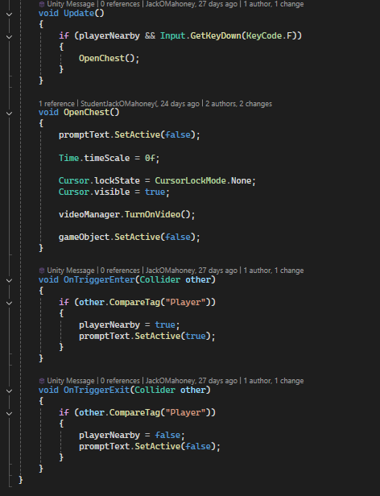

- Propper code placement
This is proper organization of the code into logical scripts or folders so in my case of my project I have separate managers for different systems aswell as folders to sort the scripts into their specific purpose that their for like my BuffManager and PanelManager
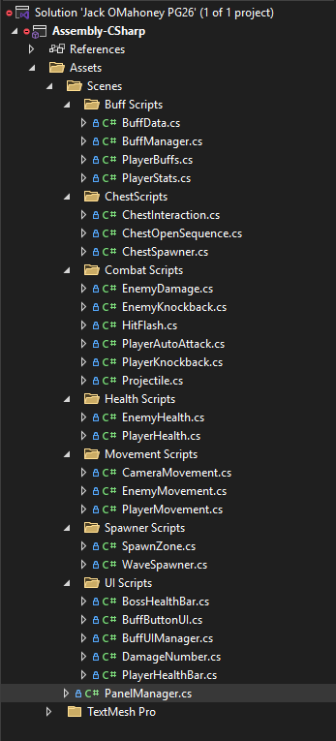

- Code repetition
This is just Avoiding duplicating code and I have used this in my buff system where I have my ApplyBuff( ) which is a single function that handles the applying of all the buffs and my BuffData Script which is a reusable structure I can use to handle creating as many buffs that I need.
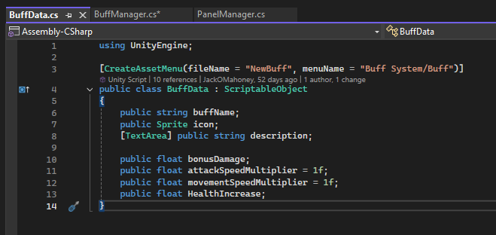
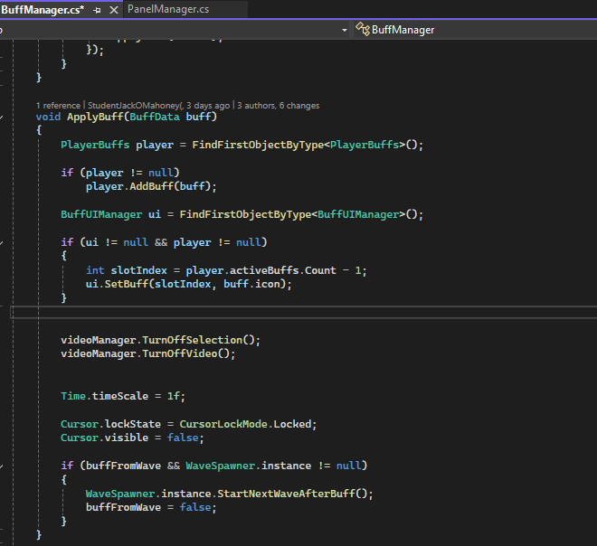

- Feature 1 Chest Interaction System/Video
In my project I have added a system that allows the player that’s close enough to a spawned in chest model they will be prompted to press F to open the chest which will then play a video of the chest opening followed by the buff selection system.
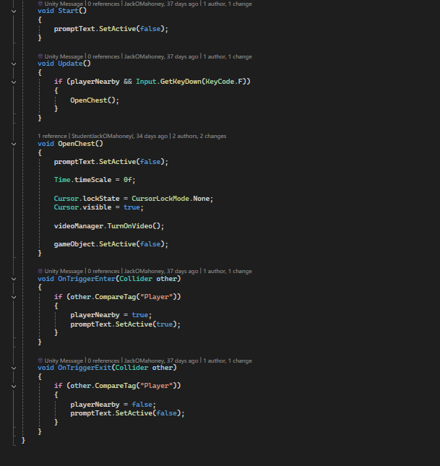

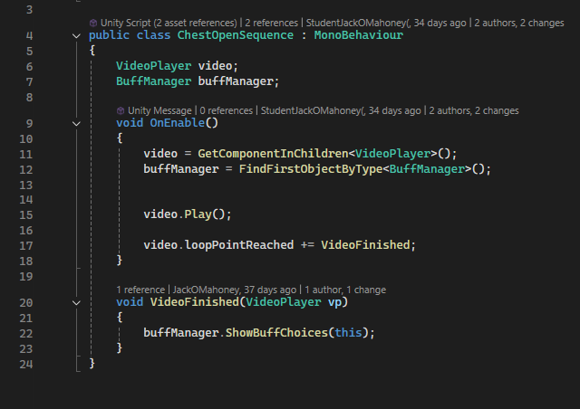
- Feature 2 Floating Damage Numbers
I have made in there project where when the projectile hits an enemy floating damage numbers will appear over the enemy.
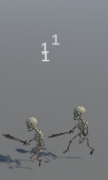
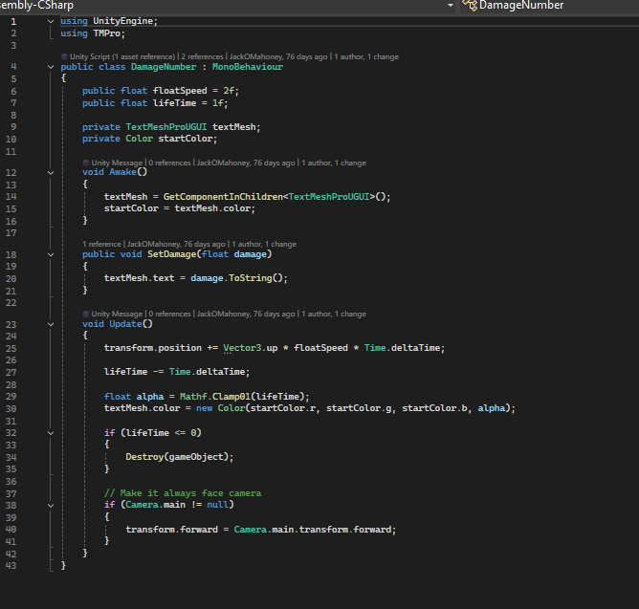
- Feature 3 Buff Selection System
I have a selection system so whether the wave ends or a chest is opened 3 buff options will appear and allow the player to buff up for the next wave
